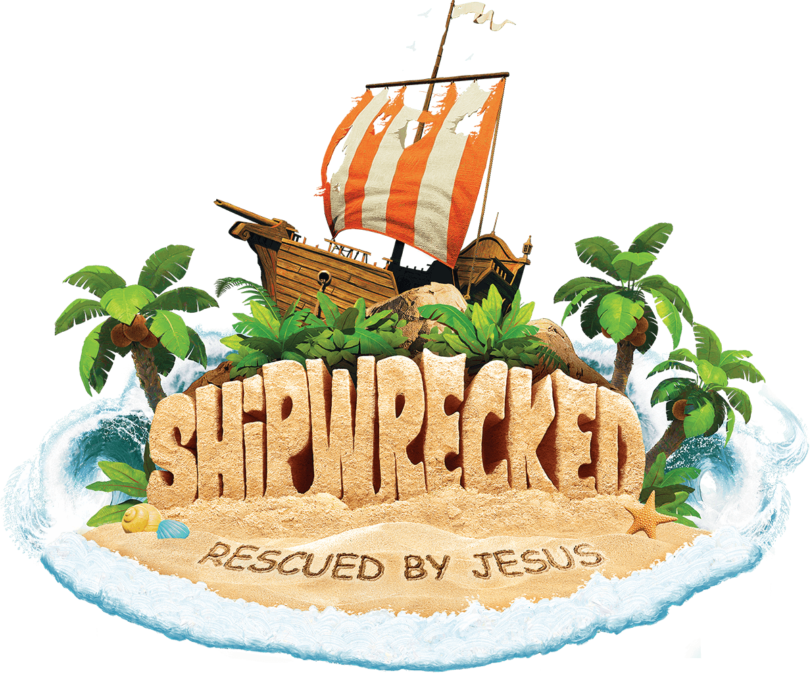
VBS REGISTRATION
July 16-20th Dinner at 5pm VBS 5:30-8:30pm
Students entering grades K-5th, join us for a week of fun at SHIPWRECKED!
We will learn that Jesus rescues us when life gets stormy.

Child’s Name: __________________________________ Child’s Gender: ________Entering Grade: ________
Sibling 1: ______________________________________ Child’s Gender: ________ Entering Grade: ________
Sibling 2: ______________________________________ Child’s Gender: ________ Entering Grade: ________
Parent Name: _______________________________________________________________________________
Street Address: ______________________________________________________________________________
City: __________________________ Zip Code:_______________ Phone Number: _______________________
Emergency Contact & Phone Number: __________________________________________________________
List Allergies: _____________________________________________________________________________
Addition Information we need to be aware of: _____________________________________________________

__________________________________________________________________________________________

Questions?
Contact Sierra Moore
VBS Director
(805) 509-3918
smoore@stjohnsoxnard.com

